**A System to Reserve Tables in a Restaurant**

**UIT2211 - SOFTWARE DEVELOPMENT PROJECT – I**

**A PROJECT REPORT**

**Guided by**

**Dr. Josephine Julina J K**

**Assistant Professor, Department of IT.**

**Submitted by**

**Naveensivam S - 3122235002077**

**Navin V - 3122235002078**

**Neelesh Panchumarthi - 3122235002079**

**Nikhil S - 3122235002080**

**SSN COLLEGE OF ENGINEERING,**

**KALAVAKKAM**

**JUNE 2024**

**Sri Sivasubramaniya Nadar College of Engineering**

**(An Autonomous Institution, Affiliated to Anna University)**

**BONAFIDE CERTIFICATE**

Certified that this project titled “A system to reserve tables in a restaurant” is the bonafide work of “Naveensivam S – 3122235002077, Navin V – 3122235002078, Neelesh Panchumarthi – 3122235002079, Nikhil S – 3122235002080”, and is submitted for project viva-voce examination held on 22.06.2024.

**Signature of examiner(s)**

**ACKNOWLEDGEMENT**

We would like to express our sincere gratitude to Dr.Josephine Julina J K and Dr. V. Durgadevi who gave us the golden opportunity to work on this project and also a special thanks to them for their constant guidance and support throughout the project.

Secondly, we would also like to thank our parents, relatives and friends who constantly supported and motivated us to complete the project within the limited time frame.

We are highly obliged to all those who guided and helped us out in completing this project successfully.

**TABLE OF CONTENTS**

|  |  |
| --- | --- |
| **1. INTRODUCTION** | **5** |
| **2. AGILE METHODOLOGY** | **11** |
| **3. PROBLEM STATEMENT** | **24** |
| **4. LITERATURE SURVEY** | **25** |
| **5. REQUIREMENTS** | **28** |
| **6. TECHNOLOGY ASSESSMENT** | **30** |
| **7. DESIGN AND DEVELOPMENT OF SOLUTION** | **33** |
| **8. PROCESS MANAGEMENT** | **37** |
| **9. DEPLOYMENT** | **39** |
| **10. GAP ANALYSIS** | **45** |
| **11. CONCLUSION** | **50** |

# CLIENT CERTIFICATE

* **Name of the project:** Restaurant Table Reservation System
* **Client details:**
* **Name:** Mr. Vishwanathan
* **Address:** 25, Kaliamman Koil St, Chinmaya Nagar Stage 2, Natesan Nagar, Virugambakkam, Chennai, Tamil Nadu 600092
* **Contact:** 08610886376

**Rating System - 1: Strongly disagree 2: Disagree 3: Neutral 4: Agree 5: Strongly Agree**

|  |  |  |  |  |  |
| --- | --- | --- | --- | --- | --- |
| QUESTION | 1 | 2 | 3 | 4 | 5 |
| The problem was well discussed and the requirements and goals were clear. |  |  |  |  | ✔ |
| The project plan was well defined and communicated from the start. |  |  |  | ✔ |  |
| The resources were adequate for achieving the goals. |  |  |  | ✔ |  |
| The original timeline was realistic and was followed. |  |  |  | ✔ |  |
| The teamwork was well demonstrated. |  |  | ✔ |  |  |
| The client was communicated on regular intervals and given updates on the progress of the project. |  |  |  | ✔ |  |
| The expected project requirements have been satisfied |  |  |  |  | ✔ |



**Signature of the client**

# CHAPTER 1

# INTRODUCTION

The purpose of this project is to present "Restaurant Table Reservation System", an innovative system designed to efficiently manage the occupancy of tables in a restaurant. Our Restaurant Table Reservation System leverages advanced technologies to provide a comprehensive solution for booking tables in a restaurant, ensuring a smooth dining experience for all the customers.

### **RESTAURANT TABLE RESERVATION**

Restaurant Table Reservation System is a cutting-edge system that revolutionizes the management of occupancy of tables in the restaurant by utilizing the power of Python, the various data structures present in it and CSV Files. Developed with these robust technologies, Restaurant Table Reservation System offers the restaurant manager and customers a dynamic and engaging platform to book tables depending on the number of seats, track the tables occupied, and bill payment operations.

Python, known for its robustness and versatility, serves as the core programming language for Restaurant Table Reservation System. Its extensive libraries and frameworks enable the application to deliver advanced functionalities, seamless data processing, and efficient algorithms for occupancy management.

CSV files, a simple and widely-used format for tabular data, serve as a crucial component in the Restaurant Table Reservation System for data storage and transfer. They enable seamless import and export of user and property information, ensuring compatibility with various software tools and ease of data manipulation.

The user interface of the Restaurant Table Reservation System is developed using Tkinter, Python's standard GUI library, ensuring a functional and interactive desktop application. Tkinter provides the essential tools to create windows, dialogs, and various user interface elements, making it possible to design a comprehensive and responsive management system.

The combination of Tkinter's widgets and its ease of use allows Restaurant Table Reservation System to offer a seamless and efficient experience for displaying the available and occupied tables, tracking the details of the tables occupied, and handling the bill payment of each individual table, all within a cohesive desktop environment.

The collaborative efforts of Tkinter, Python, data structures in Python, and CSV files in the Restaurant Table Reservation System result in a feature-rich desktop application. The restaurant manager can have a look at the tables which are currently occupied, update occupancy status by paying bill of a particular table, while customers can easily access information about available and occupied tables, enter the number of seats required by them, and view the changes which occur after table booking. This fosters a sense of organization and involvement between the restaurant manager and the customers.

The integration of Python and Tkinter enables the application to leverage advanced algorithms and data structures for managing and displaying data related to occupancy of tables, providing restaurant managers with a comprehensive overview of tables occupied and their details. Tkinter's robust GUI elements ensure a user-friendly and interactive experience.

One of the key features of the Restaurant Table Reservation System is its use of CSV files for data storage. CSV files provide a simple and widely-compatible way to store and retrieve tabular data, ensuring easy data manipulation and portability. The integration of Python with CSV files allows for efficient data processing and retrieval, enhancing the overall performance and reliability of the application. Python's versatile data structures, such as lists and dictionaries, facilitate the organization and management of data, ensuring that the system remains responsive and scalable.

In conclusion, Restaurant Table Reservation System is a modern housing management system that harnesses the power of Python, Tkinter, data structures in Python, and CSV files. These technologies come together to create a dynamic and user-friendly desktop application, facilitating seamless management and interaction with the customers. The use of CSV files ensures efficient and flexible data management, making Restaurant Table Reservation System a reliable and efficient platform for overseeing the occupancy of tables.

Tkinter provides an interactive and intuitive graphical user interface, while Python's robust capabilities and data structures such as lists and dictionaries ensure efficient data processing and organization. The combination of these elements results in a responsive and scalable system, enhancing both the restaurant manager and the customer experience.

### **METHODOLOGY**

The development of the Restaurant Table Reservation System platform was guided by the principles of Agile methodology, ensuring a flexible and iterative approach to software development. This methodology was chosen due to its emphasis on collaboration, adaptability, and incremental progress, which were crucial for meeting the dynamic needs of restaurant manager and customers.

### **Key Aspects of the Methodology**

1. **Requirements Gathering:** Extensive research methods, including surveys, interviews, and focus groups, were employed to gather comprehensive requirements. This helped in understanding the specific challenges faced by restaurant managers and customers, ensuring that Restaurant Table Reservation System was tailored to meet their needs.
2. **Design and Planning:** The design and planning phase involved creating detailed wireframes, user interface mockups, and the overall architecture of the platform using various efficient project management tools. The focus was on creating an aesthetically pleasing and intuitive interface that would resonate with both administrators and customers.
3. **Technology Selection:** The frontend was developed using Python and Tkinter, whereas CSV files were used for retrieval and storage of data. Tools like GitHub were used for version control and code repository management, facilitating collaborative development and maintaining a complete history of code changes.
4. **Development:** The development phase translated the design and architecture into a fully functional occupancy management system. This involved implementing user interfaces, and interactive features on the frontend, and establishing secure database connectivity and advanced algorithms for backend functionalities.
5. **Testing and Quality Assurance:** Rigorous testing, including various test scenarios and user acceptance testing, was conducted to ensure functionality, usability, and security. This phase aimed to identify and address bugs, glitches, or performance issues to enhance the platform's overall quality.
6. **Deployment:** After thorough testing and resolution of identified issues, Restaurant Table Reservation System was deployed on servers or hosting platforms, making it accessible to restaurant managers and customers. This final step marked the culmination of meticulous planning, design, and development efforts.

### **OBJECTIVES**

The Restaurant Table Reservation System project, developed at the college level, encompasses the following key objectives:

* + 1. With the current paradigm shift in the technological field, there is an urgent need to embrace and appreciate the power of technology. Restaurants remains vigilant to face the challenges of change by employing a new strategy that facilitates easy management of occupying tables. Hence there is a need to develop a restaurant table reservation system that can simplify work for the restaurant managers so that all their work can be efficient and effective.
    2. Our aim is to create a simple GUI that can allow the user to book a table and enables the restaurant manager to manage the occupancy of the tables easily and effectively. To develop this system, we have used the Tkinter module in Python as our frontend and in the backend, we have used CSV files to store data.

This system has two login modules where-in each module has a different functionality.

* + 1. **RESTAURANT MANAGER MODULE** – In this login portal, only the restaurant manager will be able to login and see the details of the customers who are seated in a particular table.
    2. **CUSTOMER MODULE** – Here the customers who are willing to eat in the restaurant will be able to login through this portal. The customers should enter their name, mobile number and their email ID in this portal.

This system will help the customers to get a table depending on the number of seats they require. This online restaurant table reservation system will reduce paperwork and make things simpler.

* + 1. **Develop Better Connections and Meaningful Interactions Among Customers:** The Restaurant Table Reservation System aims to create a cohesive and vibrant environment within the restaurant where customers can connect, share their experiences, and engage in meaningful interactions. The Restaurant Table Reservation System helps to develop better connections and encourages customers to maintain good relations with the restaurant.

By specifically targeting the needs of customers, The Restaurant Table Reservation System provides a unique platform where customers can easily look at the tables that are available and those which are occupied, book tables depending on their seat requirements, and get updated information regarding the same. The integration of relevant notifications supports customers in staying informed and involved with the restaurant, promoting their overall well-being and satisfaction.

### **MOTIVATION**

The software is needed to provide customers with a better and an easier way of booking a table in a restaurant with little hassle. Reserving a table at a popular restaurant can often be a daunting task, especially in bustling cities like Chennai where the dining scene is always vibrant and competitive. The challenges involved in securing a reservation are often seen as an unavoidable part of the dining experience. Our new idea for Restaurant Table Reservation System questions that behavior and motivates them to switch to a hassle-free experience.

The motivation behind developing Restaurant Table Reservation System project stems from recognizing the unique challenges and needs that restaurant managers and customers face in their daily interactions and operations. Managing a restaurant involves various tasks, from maintaining occupancy records of each table to addressing billing requests, all while maintaining harmony among customers. Restaurant Table Reservation System aims to bridge these gaps by providing a tailored platform that focuses on streamlining operations and enhancing the dining experience for all customers.

The motivation behind the development of Restaurant Table Reservation System project can be summarized as follows:

* + 1. **Streamlining Management Operations:** Managing a restaurant involves numerous administrative tasks, including tracking occupancy of tables, managing billing requests, and storing customer data. Restaurant Table Reservation System seeks to provide a centralized platform that simplifies these tasks, making it easier for restaurant managers to maintain an organized and efficient operation.
    2. **Facilitating Organization and Interaction:** Effective organization is crucial in a restaurant to ensure that customers do not face any hassles and are properly treated with respect. Restaurant Table Reservation System aims to create a vibrant ecosystem where customers can easily communicate with restaurant manager and each other.
    3. **Enhancing Customer Satisfaction:** Customers often face challenges in reserving tables and staying informed about special promotions. The Restaurant Table Reservation System integrates features such as an online reservation system and notification alerts, which support customers in planning their dining experiences efficiently. By improving these interactions, the platform aims to enhance customer satisfaction and overall dining experience.
    4. **Providing Data-Driven Insights:** Effective management requires access to reliable data and insights. Restaurant Table Reservation System offers analytics and reporting tools that provide restaurant managers with valuable information on occupancy trends, maintenance issues, and customer feedback. These insights help in making informed decisions, improving management practices, and proactively addressing potential issues.

The motivation behind our project lies in empowering restaurant managers, enhancing customer experiences, and fostering a sense of belonging. By addressing the specific needs of the restaurant managers and the customers, Restaurant Table Reservation System aims to improve operational efficiency, customer satisfaction, and overall well-being. Through its comprehensive features and user-centric design, our project contributes to a harmonious and well-managed dining environment.

**CHAPTER 2**

**AGILE METHODOLOGIES**

Agile methodology is a collaborative and iterative approach to project management and software development that emphasizes flexibility, adaptability, and customer involvement throughout the process. It revolves around delivering value in short iterations known as sprints, embracing change, and fostering continuous improvement. Agile teams work together in a highly collaborative and cross-functional manner, with regular feedback and communication. This methodology promotes transparency, empowers team members to make decisions, and enables quick responses to changing requirements. By embracing Agile, organizations can improve productivity, quality, and customer satisfaction by delivering incremental and iterative solutions. Scrum, an Agile framework, focuses on iterative and incremental product development. It involves self-organizing, cross-functional teams that work in short sprints. Key components of Scrum include daily stand-up meetings, product backlogs, and sprint reviews, which promote transparency, collaboration, and the rapid delivery of value. Throughout our project, we have adopted the Scrum Methodology, incorporating it into various sprints and organizing our requirements as user stories assigned to each team member. We have implemented Scrum methodology using JIRA software.

**METHODS ADOPTED**

1. **Jira as a Project Management Tool:** Jira was utilized as the primary project management tool to plan, track, and manage the development process. It facilitated efficient task management, backlog prioritization, sprint planning, and progress tracking. Jira's user-friendly interface allows the development team to create and assign tasks, set priorities, and monitor the progress of each sprint. This allowed for better coordination and improved visibility into the project’s status.
2. **Sprint Structure:** The development process was divided into sprints, each lasting two weeks. Sprints are timeboxed iterations that allow the team to focus on delivering a set of features or functionalities within a defined timeframe. The short duration of two-week sprints allowed for quicker feedback, frequent retrospectives, and the ability to adapt and respond to changing requirements.
   1. **SPRINT #1**

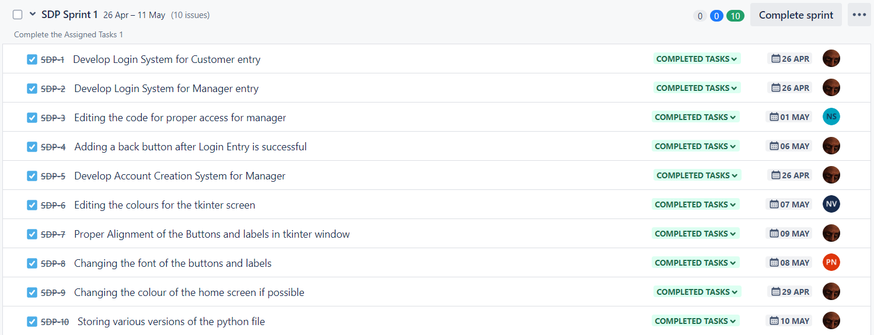

* 1. **SPRINT #2**

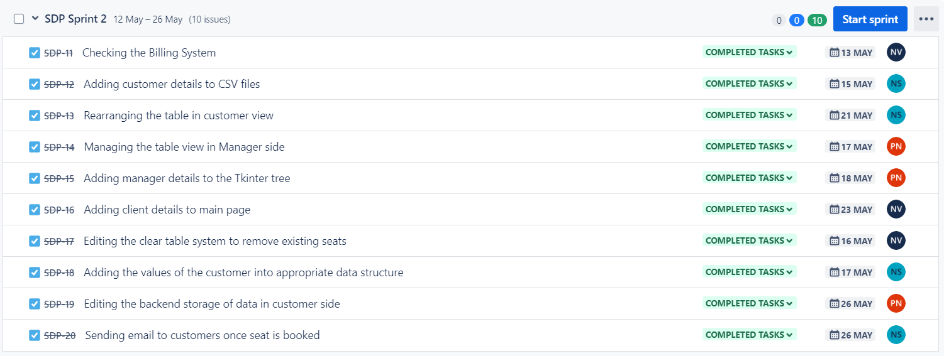

* 1. **TIMELINE**

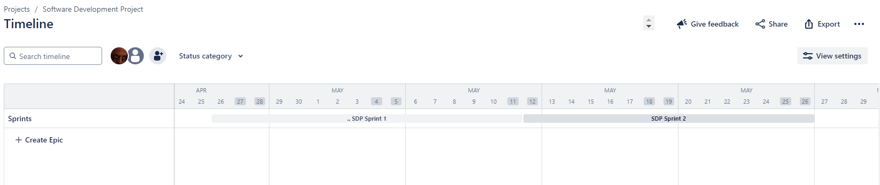

* 1. **STORY WORKFLOW**

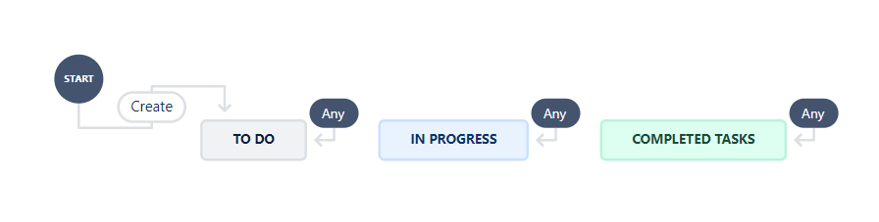

1. **PROJECT PROGRESS**

The project progress can be seen with the help of the graph. We attached three different types of report chart such as sprint burnup, sprint burndown and cumulative flow diagram for each diagram.

**2.5 SPRINT BURNP CHART FOR SPRINT 1**

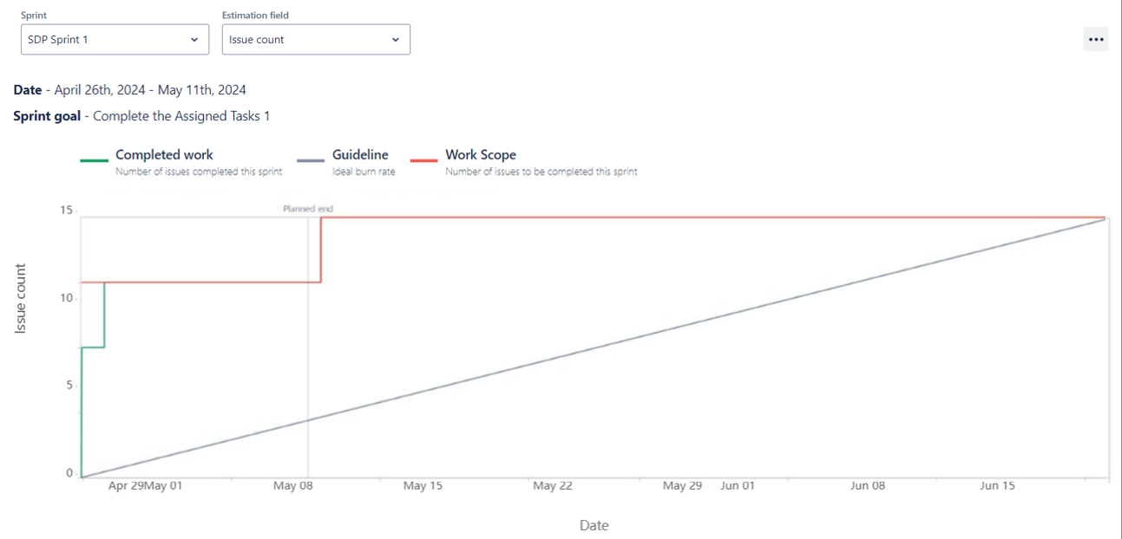

**2.6 SPRINT BURNUP CHART FOR SPRINT 2**

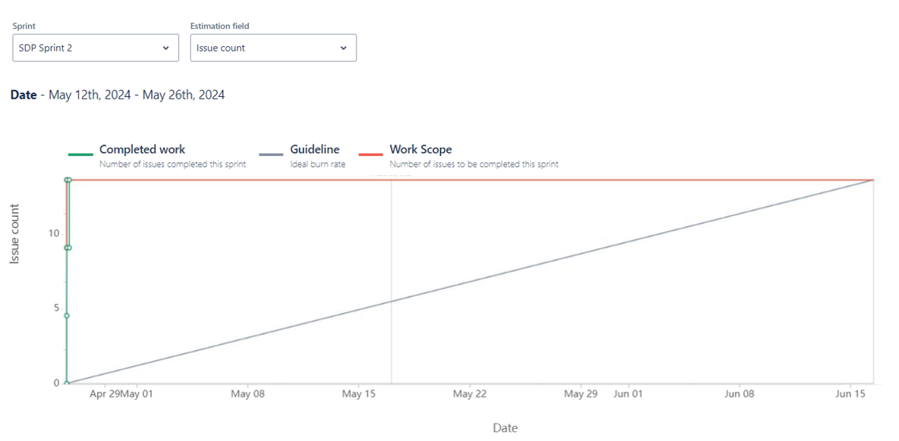

**2.7 SPRINT BURNDOWN CHART FOR SPRINT 1**

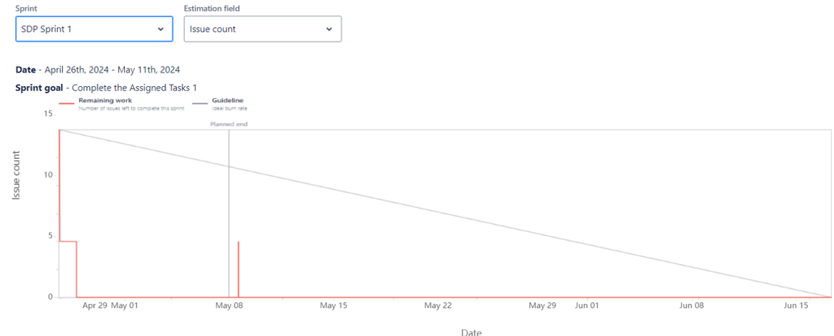

**2.8 SPRINT BURNDOWN CHART FOR SPRINT 2**

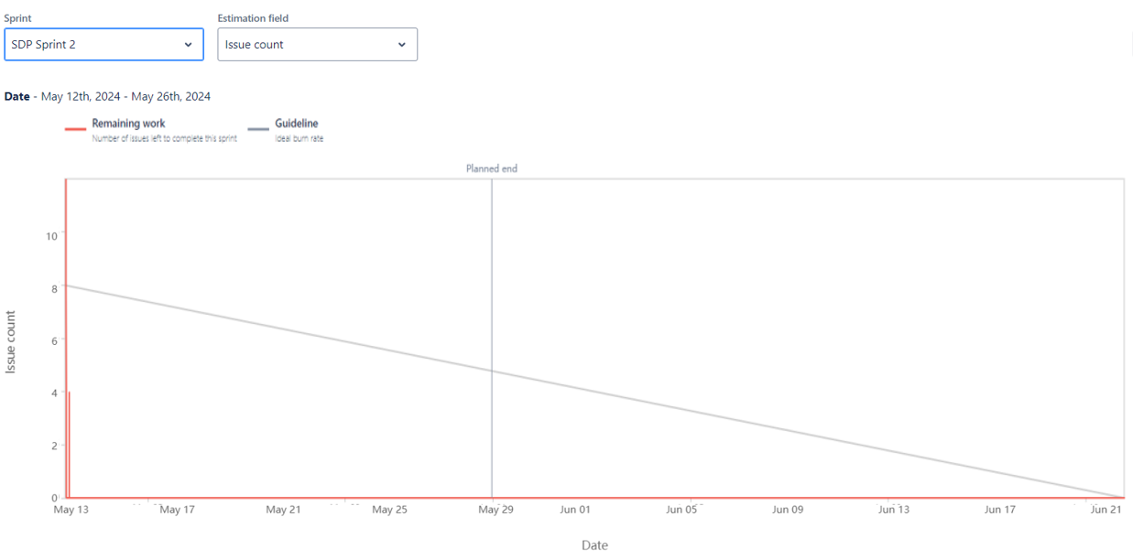

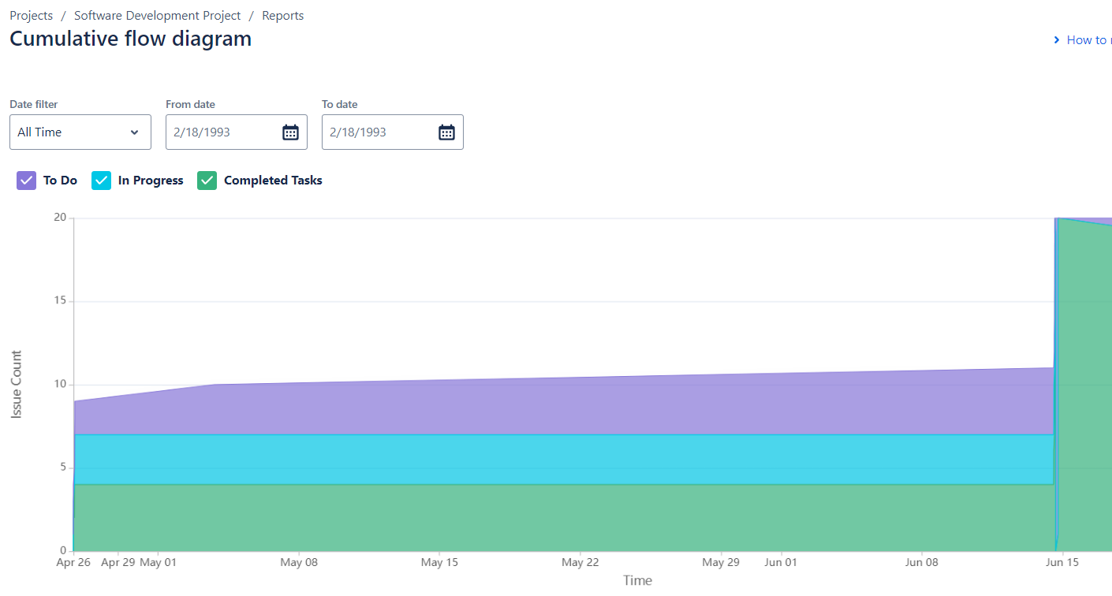

**Jira and Confluence:**

Jira and Confluence are two powerful tools that played a significant role in our social media application project. Jira is an issue tracking and project management tool, while Confluence is a collaborative documentation platform. These tools extended beyond our syllabus, providing essential functionalities and features that greatly contributed to our project's success.

**Confluence:** Confluence played a crucial role in our project's documentation and knowledge sharing efforts. It provided a collaborative platform where team members could create, edit, and share project-related documents, meeting notes, requirements, and design specifications.

With the help of Confluence, we have made product requirements, design decision and meeting Notes as shown in the figures below.

**2.9 Given below are the product requirements using Confluence**

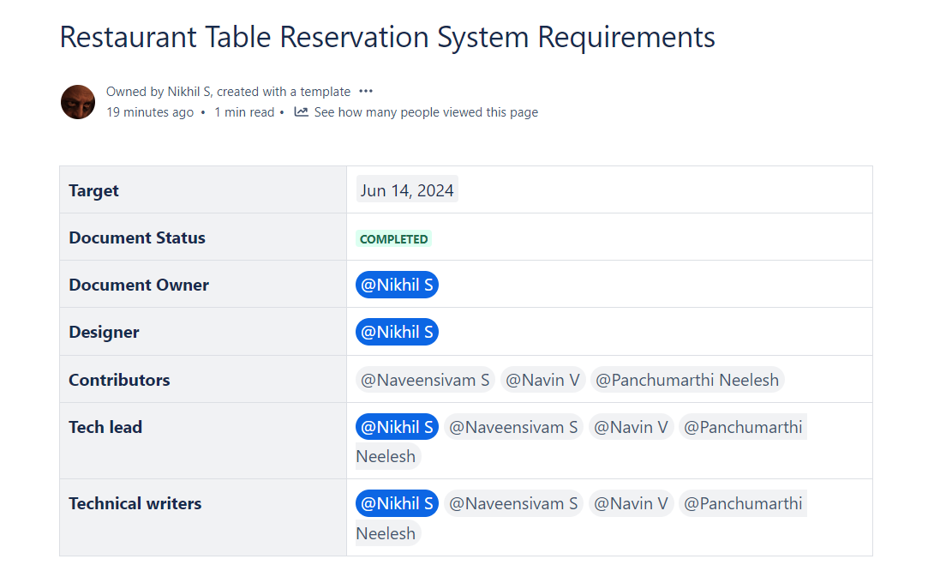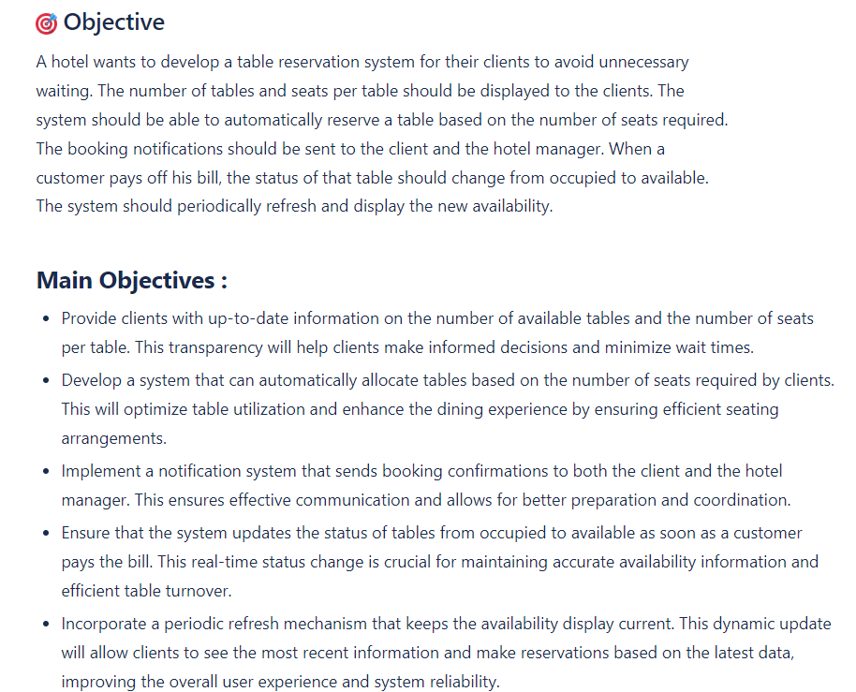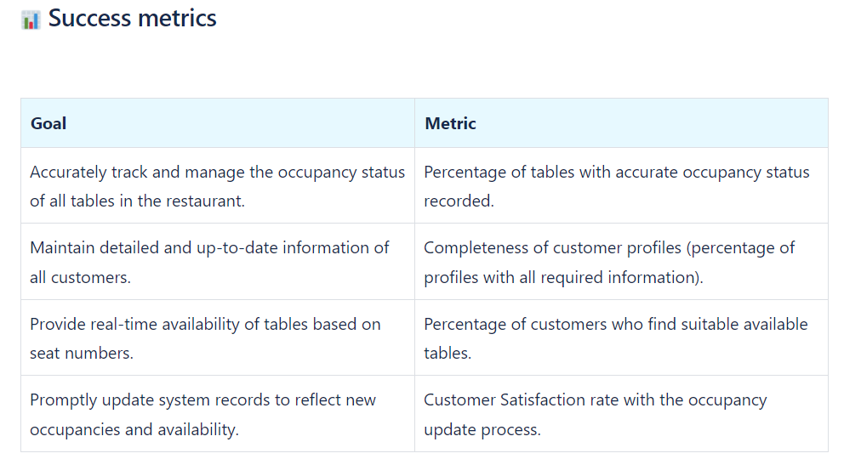

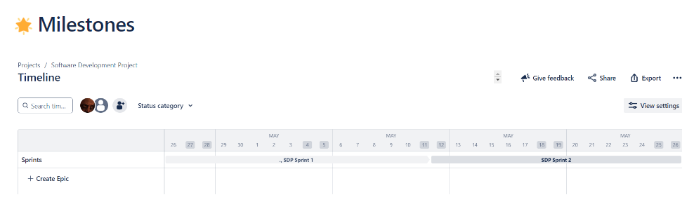

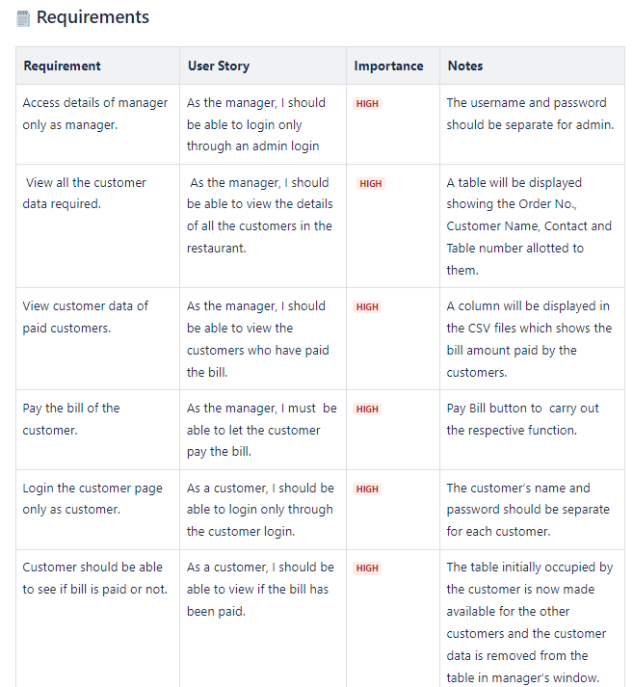

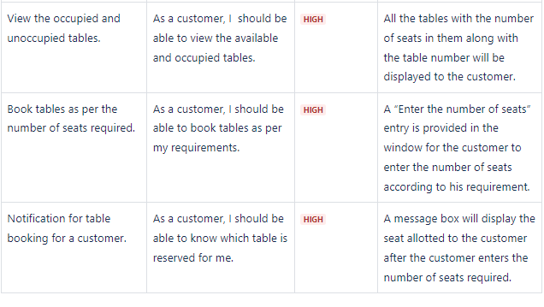

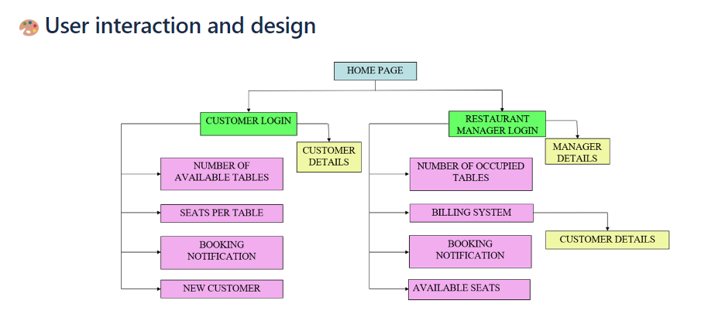

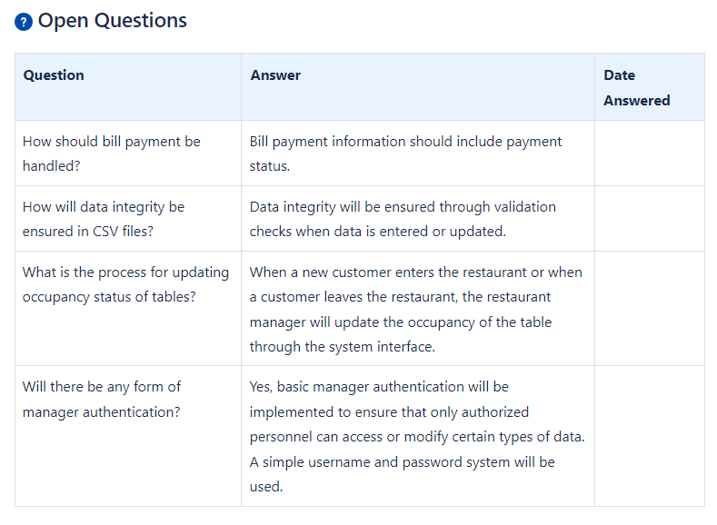

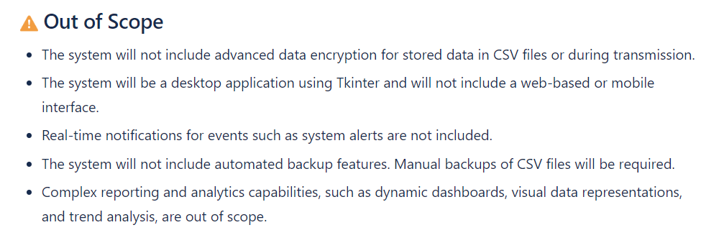

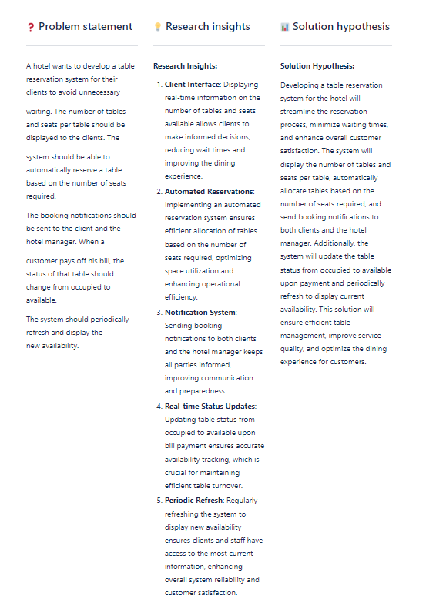**2.10. Given below are the decision designs using Confluence**

# 

# 2.16 Given below is the meeting notes using Confluence

# 18th May, 2024

**Conclusion:**

The incorporation of Jira and Confluence into our restaurant project provided us with powerful project management, tracking, documentation, and collaboration capabilities. Jira's robust project management features allowed us to effectively track tasks, manage workflows, and ensure project transparency. Confluence, on the other hand, facilitated collaborative documentation, knowledge sharing, and streamlined communication among team members. The integration between Jira and Confluence enhanced the overall efficiency of our project by seamlessly connecting project management and documentation. By leveraging these tools, we were able to optimize our project workflows, improve collaboration, and deliver a more streamlined and cohesive project outcome. By embracing Agile methodologies and utilizing Jira and GitHub, the development team of apartment management effectively managed the development process, fostered collaboration, and ensured timely delivery of features. The Agile approach facilitated flexibility, adaptability, and continuous improvement, enabling the team to respond to changing requirements.

# CHAPTER 3

# PROBLEM STATEMENT

“A hotel wants to develop a table reservation system for their clients to avoid unnecessary waiting. The number of tables and seats per table should be displayed to the clients. The system should be able to automatically reserve a table based on the number of seats required. The booking notifications should be sent to the client and the hotel manager. When a customer pays off his bill, the status of that table should change from occupied to available. The system should periodically refresh and display the new availability.”

**EXPLANATION:** To enhance customer service and streamline the dining experience, a restaurant is developing an advanced table reservation system. This system will provide real-time information on the number of available tables and the number of seats per table, enabling clients to make informed decisions without unnecessary waiting. The system will automatically allocate a table based on the number of seats required by the client. This ensures efficient use of space and maximizes the dining room's capacity. Upon successful reservation, notifications will be sent to both the client and the hotel manager. This ensures that both parties are aware of the booking details and can prepare accordingly. When a customer completes their meal and pays the bill, the system will update the status of the table from occupied to available. This real-time status change helps in maintaining an accurate display of table availability. The system will periodically refresh its data to display the latest availability of tables. This dynamic update allows clients to see the most current information and make reservations based on real-time data. Overall, this table reservation system aims to minimize wait times, enhance customer satisfaction, and improve the efficiency of the restaurant’s dining operations by providing a seamless and automated booking experience.

## CHAPTER 4

**LITERATURE SURVEY**

In this literature survey, we explore existing knowledge and research relevant to the development and implementation of a system for managing the occupancy of tables of a restaurant. This system aims to streamline the management of table occupancy and maintenance within the restaurant.

## EXAMINING SIMILAR PROJECTS

Our survey begins by examining foundational concepts in restaurant table reservation system and their evolution. We delve into the challenges faced by existing methods and the opportunities for innovation in enhancing user experiences. By exploring the current landscape, we identify gaps where the new system can offer substantial improvements.

Next, we investigate the technologies required for developing the restaurant management system. Key languages such as Python was highlighted for their role in building robust interfaces and functionality. Relevant literature discussing the strengths and optimal practices of this language in similar applications is reviewed.

The survey also explores algorithms pertinent to the system’s functionalities, particularly those involved in managing occupancy of tables and displaying table availability. By examining research on algorithms used in related contexts, we assess their effectiveness and suitability for the ecosystem management system.

## EXPLORATION ON THE DATABASE

## Furthermore, we analyze the role of CSV files in data management within the system. CSV's simple format and compatibility with various data processing tools make it ideal for storing and retrieving occupancy details and maintenance records. We review literature on the use of CSV files in ecosystem management systems, exploring practical applications and strategies for optimizing data handling and access.

## 4.3 ALGORITHM ADOPTED

In addition, this survey investigates algorithms employed for functionalities such as generating table occupancy reports and tracking bill payments. Algorithms chosen for automating these tasks are crucial for system efficiency and customer satisfaction. Relevant literature on algorithmic approaches in similar contexts provides insights into their application and benefits.

Through this literature survey, we gain a comprehensive understanding of the technologies and methodologies essential for developing an effective system to manage occupancy of tables within the restaurant. By synthesizing existing research and insights, we aim to inform the development and implementation phases with best practices and innovative approaches tailored to the restaurant’s specific needs.

Several key algorithms drive the efficiency of the restaurant management system. The Table Occupancy Status Algorithm (TOSA) monitors and updates real-time table occupancy data, ensuring accurate table status information. It utilizes efficient data structures for quick access and responsiveness.

Moreover, the Seats - based Availability Algorithm (SAA) categorizes tables by seat configurations, facilitating easy identification of available tables. This algorithm promptly updates availability listings as table occupancy changes occur, providing prospective customers with current table options. Complementing these, the Bill Payment Algorithm (BPA) automates billing processes, ensuring complete payment of the bill amount and maintaining financial transparency. Together, these algorithms optimize resource management and enhance restaurant operational efficiency.

# CHAPTER 5

# REQUIREMENTS

|  |  |  |  |
| --- | --- | --- | --- |
| **REQUIREMENT NO.** | **USER STORY** | **ESSENTIAL/DES IRABLE** | **DESCRIPTION OF REQUIREMENT** |
| 1 | As the manager, I should be able to login only through an admin login | ESSENTIAL | The username and password should be separate for admin. |
| 2 | As the manager, I should be able to view the details of all the customers in the restaurant. | ESSENTIAL | A table will be displayed showing the Order No., Customer Name, Contact and Table number allotted to them. |
| 3 | As the manager, I should be able to view the customers who have paid the bill. | ESSENTIAL | A column will be displayed in the CSV files which shows the bill amount paid by the customers. |
| 4 | As the manager, I must be able to let the customer pay the bill. | ESSENTIAL | Pay Bill button to carry out the respective function. |
| 5 | As a customer, I should be able to login only through the customer login. | ESSENTIAL | The customer’s name and password should be separate for each customer. |
| 6 | As a customer, I should be able to view if the bill has been paid. | ESSENTIAL | The table initially occupied by the customer is now made available for the other customers and the customer data is removed from the table in manager’s window. |
| 7 | As a customer, I should be able to view the available and occupied tables. | ESSENTIAL | All the tables with the number of seats in them along with the table number will be displayed to the customer. |
| 8 | As a customer, I should be able to book tables as per my requirements. | ESSENTIAL | A “Enter the number of seats” entry is provided in the window for the customer to enter the number of seats according to his requirement. |
| 9 | As a customer, I should be able to know which table is reserved for me. | ESSENTIAL | A message box will display the seat allotted to the customer after the customer enters the number of seats required. |

**CHAPTER 6**

**TECHNOLOGY ASSESSMENT**

In this chapter, we delve into the rationale behind the selection of languages, tools, and algorithms employed to address the problem at hand. As elucidated in preceding chapters, the solution relies on Tkinter for the front end and CSV Files is utilized for the backend.

1. **Tkinter:**
   1. Tkinter provides the fundamental structure for creating windows and dialogs, allowing for the development of a comprehensive graphical user interface for desktop applications.
   2. Tkinter's wide range of widgets, such as buttons, labels, and text fields, ensures that the interface is both functional and visually appealing, enhancing user experience.
   3. Tkinter's event-driven programming model enables interactive and responsive elements within the application, such as form submissions, real-time updates, and user notifications, improving overall user engagement and usability.
2. **CSV Files:**
3. CSV files offer a straightforward and widely-compatible format for storing tabular data, making it easy to import and export data between different systems.
4. The simplicity of CSV files ensures quick and efficient data processing, allowing for rapid reading and writing operations without the need for complex parsing.
5. CSV files facilitate data manipulation and analysis, providing a flexible solution for managing large datasets and integrating with various data analysis tools and software.

Overall, the technologies, algorithms, and languages used in Restaurant Table Reservation System are carefully chosen to address specific requirements and challenges. They enable the creation of a dynamic and visually appealing user interface, ensure efficient data management and processing, provide powerful backend support, and enhance the social and advertising experiences of users. The selection of these technologies and algorithms is driven by their proven effectiveness, wide industry adoption, and their ability to meet the unique needs of Restaurant Table Reservation System as a cutting-edge social media platform for college students.

**CHAPTER 7**

**DESIGN AND DEVELOPMENT OF SOLUTION**

This chapter discusses the proposed methodology through various use case diagrams and finally describes the system design and customer side application workflow.

### **WORKFLOW DIAGRAM**

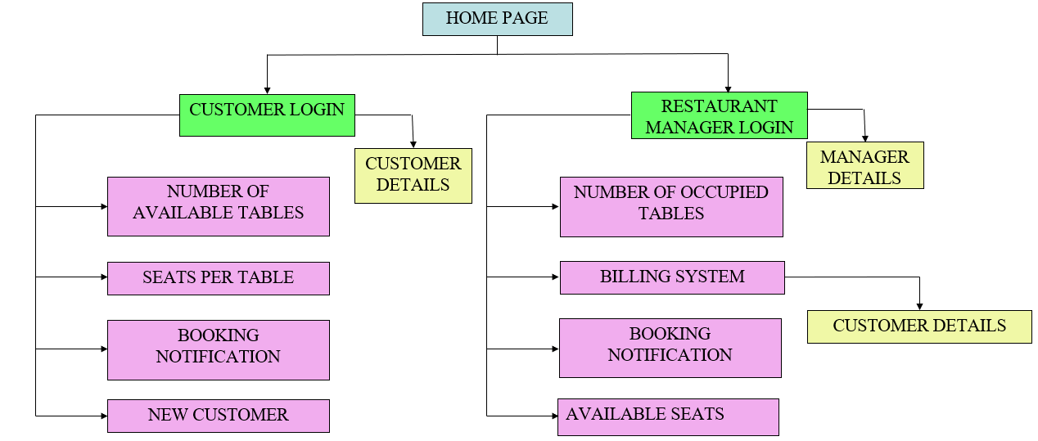

**7.2 RISK MANAGEMENT**

|  |  |  |  |  |
| --- | --- | --- | --- | --- |
| **Risk #** | **Risk Description** | **Probability** | **Impact** | **Mitigation Plan** |
| 1 | Data corruption or inconsistency in CSV files | High | Large | Implement robust error-checking and validation mechanisms when reading and writing to CSV files. Regularly backup CSV files. |
| 2 | Performance issues with large CSV files and complex data structures | High | Large | Optimize data structures (e.g., using queues) and implement efficient algorithms. Split large CSV files into manageable chunks if necessary. |
| 3 | Incompatibility issues with Python libraries | Medium | Large | Use well-supported and stable libraries. Test all libraries for compatibility with the latest Python version. |
| 4 | Data loss due to improper handling or file corruption | Medium | Medium | Implement regular backups and version control for CSV files. Ensure robust error handling and recovery mechanisms. |
| 5 | Project delays due to the complexity of data structures and UI development | Medium | Small | Break down the project into smaller, manageable tasks with realistic timelines. Use agile methodologies to adapt and refine the project plan as needed. |
| 6 | Unauthorized access to sensitive data in CSV files | Medium | Medium | Encrypt sensitive data within CSV files. Implement access controls and secure the application using authentication mechanisms. |
| 7 | Data breaches or cyberattacks | Low | Small | Regularly update the Python environment and libraries to patch vulnerabilities. Use firewalls, anti-virus software, and secure coding practices. |
| 8 | Resistance to change from the pharmacy staff. | Low | Small | Involve staff in the development process to gather input and ensure the system meets their needs. Provide training and support during and after implementation. |
| 9 | Lack of user engagement leading to underutilization of the system | Medium | Medium | Highlight the benefits of the new system and provide ongoing support to encourage its use. |
| 10 | Inefficiency in data retrieval and manipulation due to the use of complex data structures. | Medium | Medium | Optimize data access and manipulation functions. Provide training for developers on efficient use of queues. |

## CHAPTER 8

**PROCESS MANAGEMENT**

Process management plays a vital role in the successful completion of any software development project, including college projects. This article focuses on the process management approach employed in our project based on a restaurant table reservation software.

The project Python for development. while Jira was used for task management. By leveraging these technologies and implementing effective process management techniques, we were able to streamline our workflow and enhance collaboration and productivity.

1. **Project Planning:** Before diving into development, our team initiated the planning phase. We outlined the project's objectives, requirements, and scope, and created a project plan with specific milestones and deadlines. This planning phase ensured a clear understanding of the project's goals and facilitated effective task allocation.
2. **Agile Methodology:** The project team adopted the Agile methodology for our development process. Agile allowed us to break down the project into smaller tasks, known as user stories, and work on them in short iterations and sprints. This iterative approach enabled us to deliver incremental functionality and adapt to changing requirements.
3. **Task Management with Jira**: Jira, a popular project management tool, was utilized for task management. The team created user stories and assigned them to team members through Jira's issue tracking system. We could prioritize, track progress, and update the status of each task in real-time.
4. **Development Process:** The team utilized Python for developing the restaurant software. We followed a modular approach, dividing the project into logical components, such as login page, customer module, manager module and billing page. Each team member was assigned specific modules to work on, ensuring parallel development.
5. **Code Reviews:** To ensure code quality and identify potential issues, regular code reviews were conducted. Team members reviewed each other's code, providing constructive feedback and suggesting improvements. This practice helped maintain code consistency, identify bugs early, and share knowledge among team members.
6. **Testing and Bug Tracking:** Thorough testing was conducted to ensure the application's functionality, usability, and performance. Test cases were designed to cover various scenarios, and both manual and automated testing techniques were employed. Any bugs or issues encountered during testing were tracked using Jira, and necessary actions were taken to resolve them
7. **Documentation and Knowledge Transfer:** To ensure project sustainability and facilitate future enhancements, the team emphasized documentation. Knowledge transfer sessions were conducted to share insights and experiences among team members, enabling better collaboration and smoother handover.

Effective process management is crucial for the success of college projects, particularly those involving software development. By utilizing Python, the project team streamlined their workflow and enhanced collaboration. Through code reviews, testing, and documentation, the team ensured code quality and project sustainability. By embracing these process management techniques, we achieved our objectives and created a functional restaurant table reservation software.

## CHAPTER 9

## DEPLOYMENT

**AIM AND OBJECTIVES**

The aim of this chapter is to provide an overview of the project and outline its objectives. This chapter sets the context for the project report and establishes the goals that the project aims to achieve. It introduces the restaurant table reservation system developed by our team and presents the specific objectives that guided the project's development and deployment process.

**LOGIN PAGE**

Provides two different login buttons – one for the customer and the other for the restaurant manager.

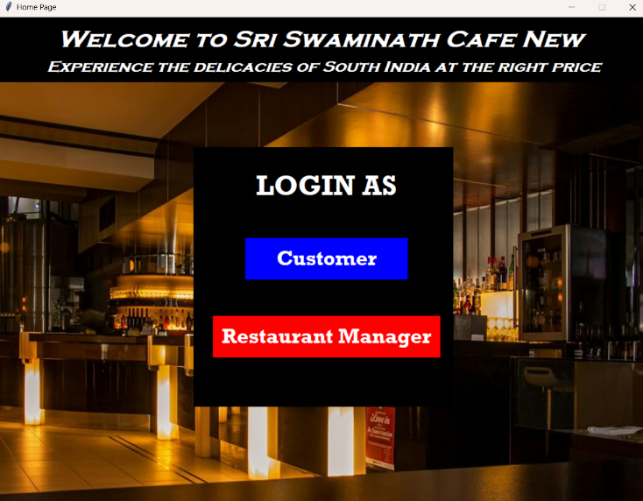

**CUSTOMER LOGIN PAGE**

Provides entries for the customer to enter their name, phone number and their email address.

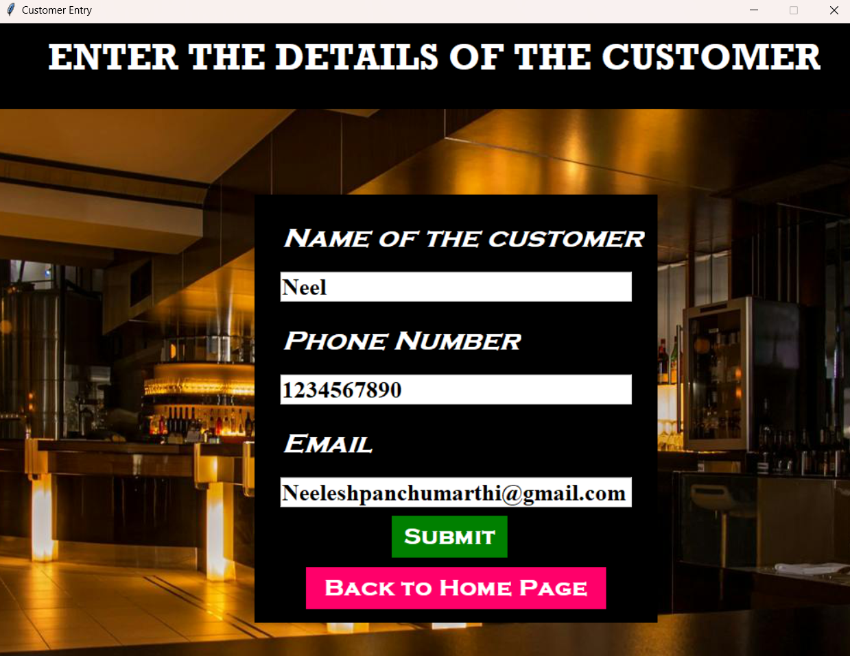

**CUSTOMER VIEW WINDOW**

This window displays the tables that are occupied by other customers and the tables that are available for other customers.

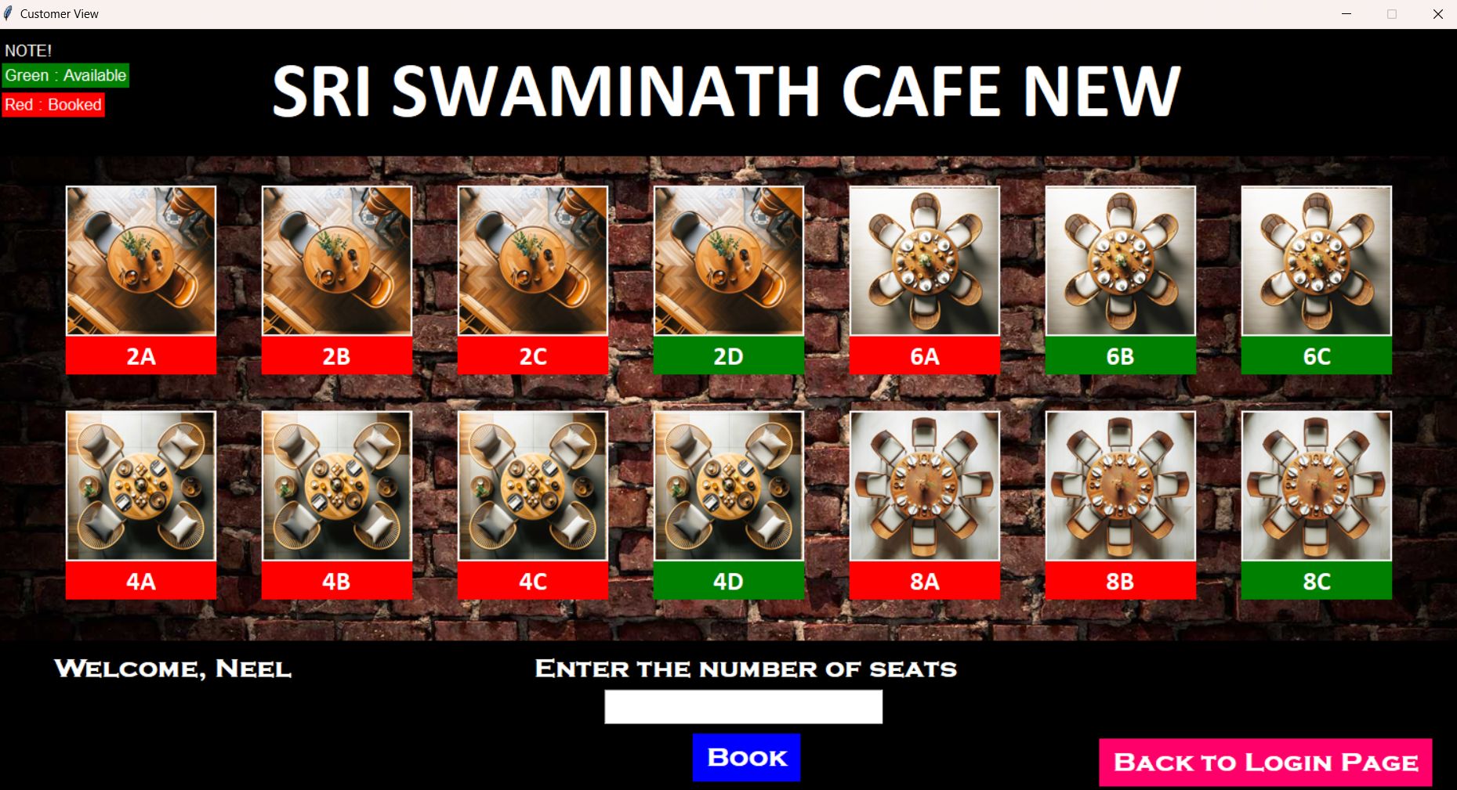

**CONFIRMATION NOTIFICATION DISPLAY**

The customer has to enter the number of seats required by them. A pop-up comes up once the table booked by the customer is successful.

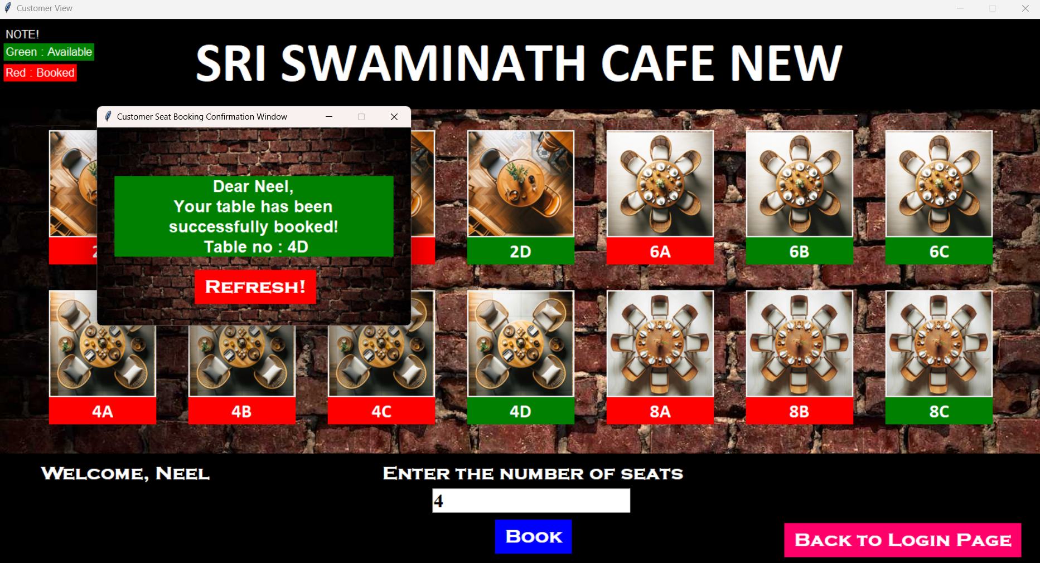

**CUSTOMER VIEW WINDOW AFTER BOOKED TABLE**

This window now displays the updated table, i.e, the table booked will be occupied now.

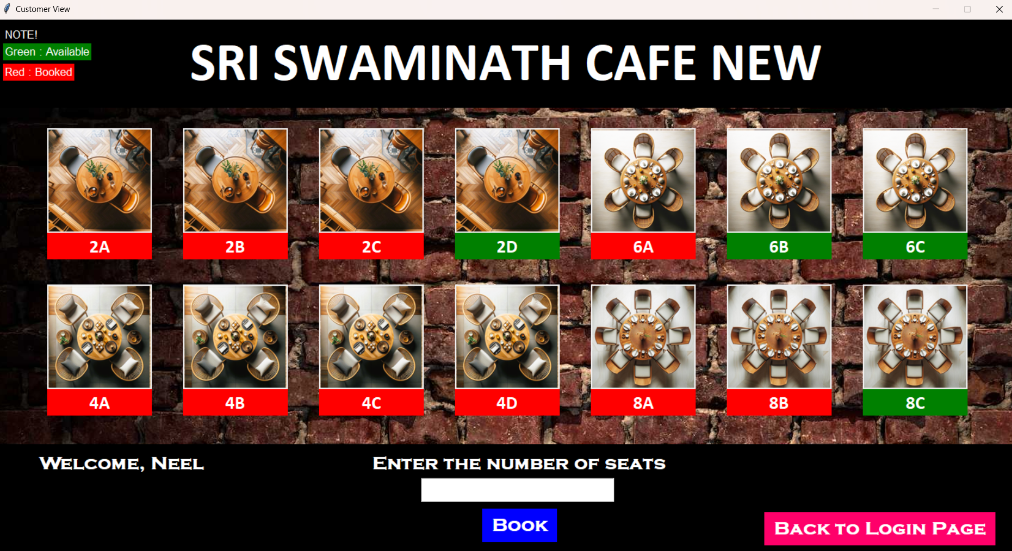

**CUSTOMER MAIL FROM ADMIN**

A mail will be sent to the customer from the manager side once the table has been booked.

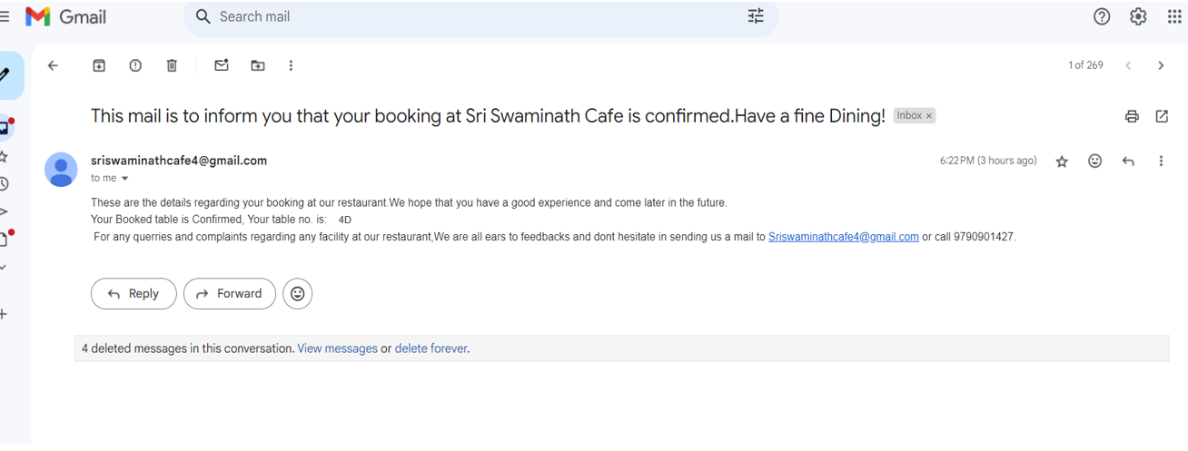

**MANAGER LOGIN**

Provides entries for the manager to enter their name, their email address and their password.

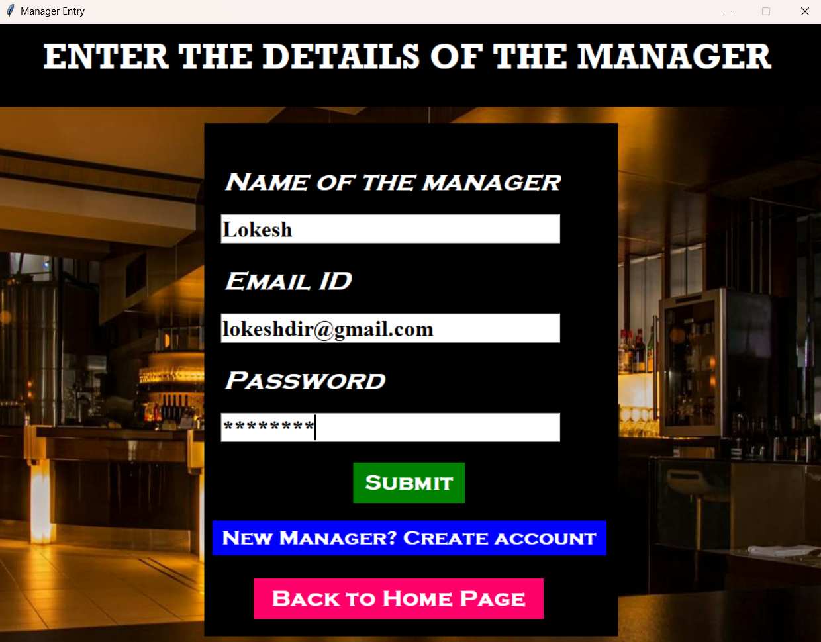

**MANAGER SIGN UP PAGE**

Provides entries for the manager to create a new account by entering their name, their email address and their password.

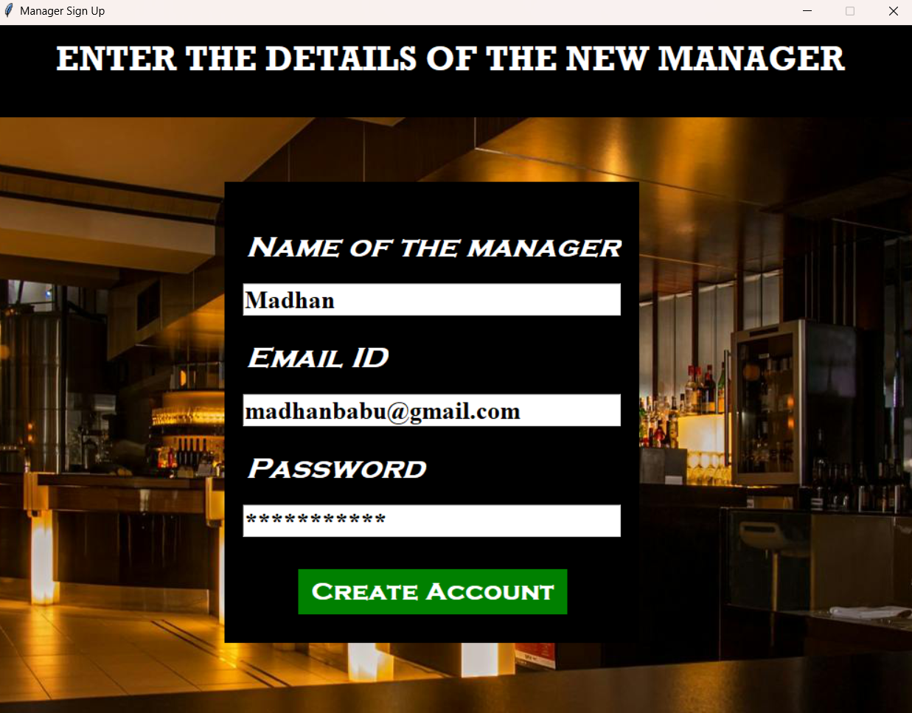

**MANAGER VIEW**

This window displays the details of the customers who have occupied the tables. It also has an option to pay the bill for an individual customer.

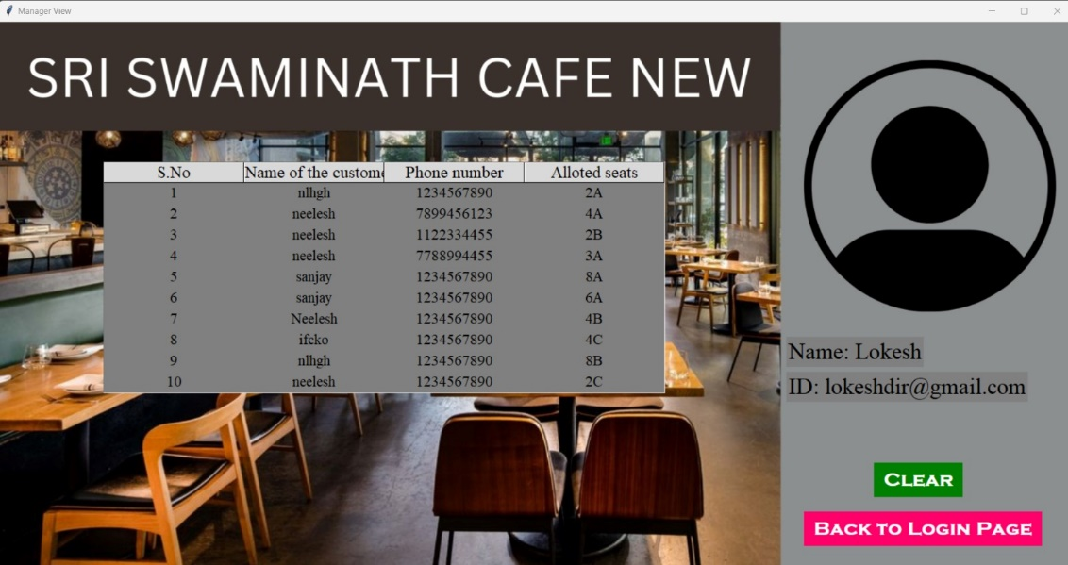

**BILL PAYMENT SYSTEM**

This window allows the manager to enter a table number for which the bill has to be paid.

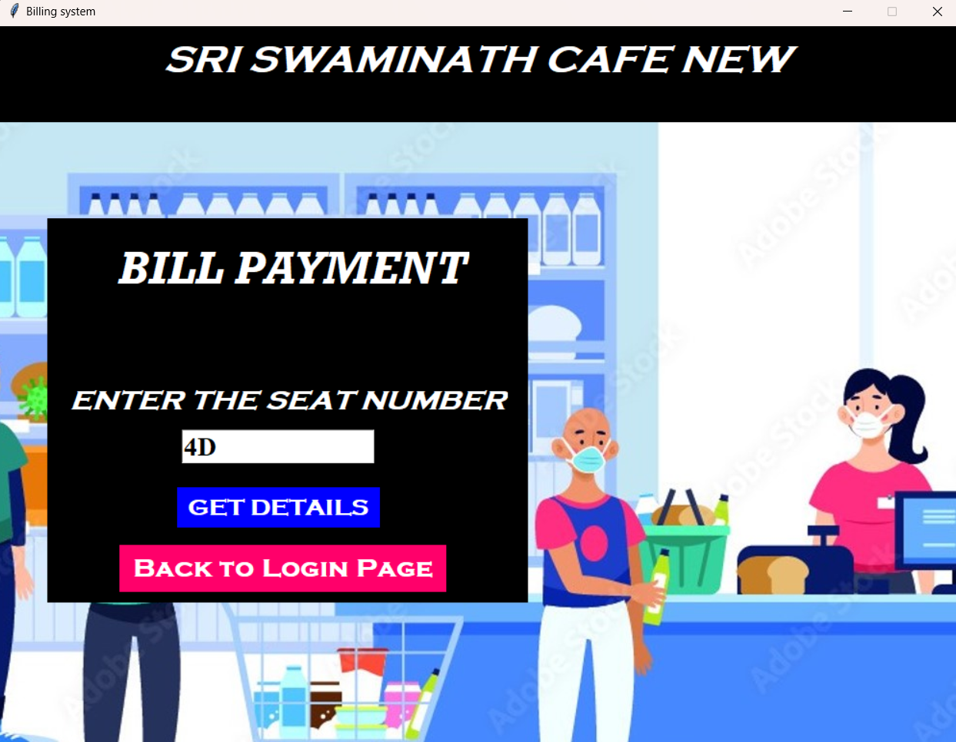

**BILL PAYMENT SYSTEM**

This window allows the manager to enter the bill amount that has to be paid by the customer to leave the restaurant.

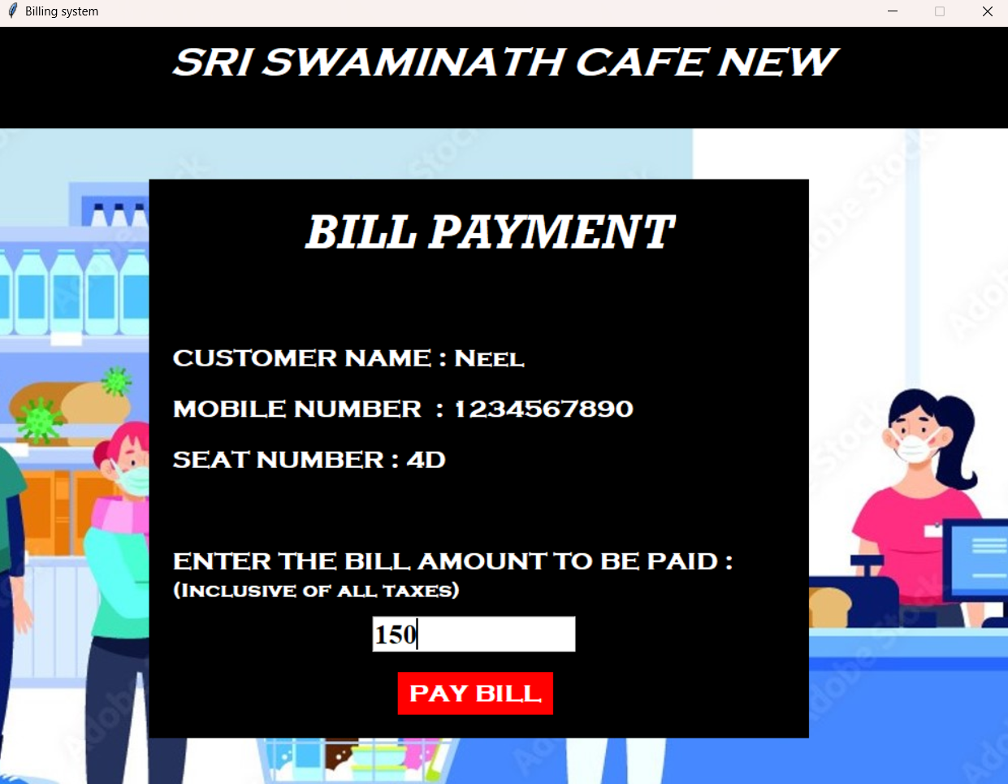

**CUSTOMER VIEW WINDOW**

This window now displays all the tables that are available and occupied and the previously booked table will now be available for the other customers.



## CHAPTER 10

## GAP ANALYSIS

During the development of our restaurant table reservation system, we ventured into unexplored territories of tools and technologies beyond our initial syllabus. These additions proved pivotal in enhancing the system's functionality, user experience, and overall effectiveness. In this comprehensive gap analysis, we delve into the specific areas where our team encountered knowledge gaps and their implications across various facets of the project. We also highlight the strategies employed to bridge these gaps, which included extensive research, proactive learning initiatives, collaboration efforts, and seeking guidance from external experts.

* 1. **Detailed Gap Analysis for Restaurant Table Reservation System:**
     1. **Project Management - Jira:**
* **Gap:** Our project did not initially include using project management tools like Jira, leading to unfamiliarity among team members.
* **Impact:** This gap affected task tracking, responsibility assignment, and progress monitoring. It hindered workflow organization and identifying potential delays.
* **Mitigation:** We learned Jira through tutorials and practical exercises. Regular team training sessions improved our project planning, task allocation, and progress tracking.
  + 1. **Database Management - CSV Files:**
* **Gap:** Our knowledge of using CSV files for data storage and retrieval was limited.
* **Impact:** Setting up efficient data management and ensuring data accuracy posed challenges.
* **Mitigation:** Extensive research and practical applications helped us integrate CSV files effectively. It simplified data handling and improved system performance.
  + 1. **GUI Development - Tkinter:**
* **Gap:**
* Integrating Tkinter with Python for GUI development was new to us.
* **Impact:** It initially slowed down the creation of interactive and user-friendly desktop applications.
* **Mitigation:** Through self-learning and collaboration, we mastered Tkinter's integration with Python. This improved our ability to develop responsive user interfaces and handle user interactions effectively.

By systematically addressing these knowledge gaps, our team successfully navigated the complexities of integrating new tools and technologies into the restaurant table reservation system. This proactive approach not only mitigated challenges but also contributed to delivering a robust and user-friendly application tailored to meet the restaurant's evolving needs effectively.

## CHAPTER 11

## CONCLUSION

* 1. **CHALLENGES**

While developing Restaurant Table Reservation System, several challenges were encountered, requiring careful consideration and mitigation strategies. The following are the key challenges faced during the development process:

* + 1. **Privacy and Data Security:** Protecting user data and ensuring privacy were significant challenges. Developing robust security measures, implementing encryption techniques, and adhering to data protection regulations required meticulous planning and rigorous testing. Establishing secure user authentication, secure data storage, and regularly updating security protocols were essential to address these challenges effectively.
    2. **User Experience and Interface Design:** Designing an intuitive, visually appealing, and user-friendly interface was a challenge. Understanding the specific needs and preferences of common customers, creating an interface that caters to their expectations, and ensuring a seamless and engaging user experience required extensive user research, iterative design processes, and usability testing.
    3. **Technological Integration:** Ensuring seamless integration and compatibility between different components, optimizing performance, and minimizing potential conflicts required careful planning and robust testing.
    4. **Competition and Market Differentiation:** Differentiating itself from existing conventional methodologies and convincing restaurant associations members to switch to or make use of platforms such as Restaurant Table Reservation System as an additional

platform required a strong value proposition, unique features, and targeted marketing strategies.

Addressing these challenges required a combination of careful planning, continuous feedback gathering, and iterative improvements. By effectively overcoming these challenges, Restaurant Table Reservation System aimed to create a platform that meets the needs of customers to book tables depending on the number of seats required by them, simplify the contact between customers and managers and provide easy access to customers and restaurant managers.

* 1. **FUTURE SCOPE**

Restaurant Table Reservation System has a promising future with various opportunities for expansion. As the platform continues to grow and evolve, several key areas of future development and expansion can be identified:

* + 1. **Mobile Application:** Develop a mobile application for both Android and iOS to provide a seamless user experience on smartphones and tablets.
    2. **Personalized Dashboards:** Implement personalized dashboards for customers and restaurant managers to provide relevant information at a glance.
    3. **Automated Bill Payment:** Integrate automated bill payment systems with online payment gateways to facilitate seamless transactions.
    4. **Table Requests and Tracking**: Introduce a comprehensive table request system where customers can submit table requests and track their status, with automated notifications for updates.
    5. **Ecosystem Forum and Messaging**: Create an internal messaging system or forum for customers and managers to communicate with each other and with management, fostering a sense of ecosystem.
    6. **Announcements and Alerts:** Enable managers to send important announcements and alerts to customers via email, SMS, or push notifications.
    7. **Waste Management Solutions**: Develop tools for efficient waste management and recycling programs within the restaurant complex.
    8. **Modular Architecture:** Design the system with a modular architecture to allow for easy scalability and addition of new features as the ecosystem grows.

These future scope areas provide exciting possibilities for the growth and evolution of Restaurant Table Reservation System. By continuously adapting to the changing needs of customers Restaurant Table Reservations can solidify its position as an excellent management platform tailored for easy communication, customer and owner data management, maintenance fee tracking and in providing a comprehensive and holistic experience for its users.